**Report Central Tendency and Percentiles**

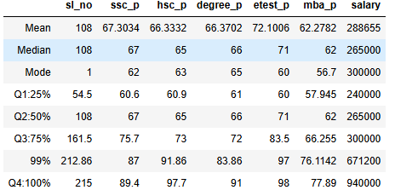

1. **Introduction:**

The report summarizes the Mean, Median, Mode and Percentile (Q1, Q2, A3 and Q4) of the Placement dataset.

The dataset includes academics percentage (ssc_p, hsc_p, degree_p, mba_p) and Salary.

1. **Measure of Central Tendency:**

* Mean (Average): The mean gives the average marks/salary.

For example, the average salary is 2,88,655 and the average E-Test percentage is 72.1006

* Median ( Middle Value): The median shows the central value when data is arranged in order.

For example, the median salary is 2,65,000 which means half of the students earned below this amount and half earned above this amount.

* Mode (Most Frequent Value): The mode represent the most common value.

For example, the mode of MBA percentage is 56.7, which means this score appeared most frequently in the dataset.

1. **Percentile** 
   * Q1 (25% Percentile): 25% of the data lies below this value.

For example, the 25th percentile of salary is 2,40,000.

* + Q2 (50% Percentile): 50% of the data lies below this value.

For example, the 50th percentile of the degree_p is 66, which means half of the students scored below 66%

* + Q3 (75% Percentile): 75% of the data lies below this value.

For example, the 75th percentile of salary is 3,00,000, meaning 75% of the students earned below 3,00,000 and 25% earned above 3,00,000.

* + Q4 (100% Percentile): 100% of the data lies below this value.

For example, the 100th percentile of salary is 9,40,000. Which means the maximum salary is 9,40,000.

**4 Observations:**

* + Students scored an average of 66% to 67% in the SSC, HSC, and Degree exams.
  + The highest average score in E-Test 72.1%
  + Salaries are highly difference: The mean salary is 2,88,655 and the maximum salary is 9,40,000 indicating some students earn much higher than the average salary.
  + The median salary(2,65,000) is lower than the mean salary.

1. **Conclusion:**

There are variation and difference in the output.